cardiovascular health in teenagers

Charan jaishreee

[Company Name]

**introduction:**

Cardiovascular health refers to the health of the pumping heart. Heart being one of the most important organs of the human body, needs to be taken care of. Resting heart rate refers to the number of times the heart pumps blood (beats) in a minute when one is relaxed or simply not preforming any strenuous activities for that moment. According to foundation (2020) a healthy heart rate for adults would be around 60-100 beats per mins. A slower heart rate may hint that the heart is working more efficiently as more blood is being pumped around by the heart every time it beats. According to Laskowski (2020) a well-trained athlete might have a resting heart rate closer to 40 beats per minute as the heart would get used to pumping more blood around the body as it would be required for the athlete when doing physical activities. Exercise also increase the rate at which energy is needed from food increasing the need for both food and oxygen by the body increasing both the pulse and heart rate. If in any case the heart is not functioning properly, it would show signs of heart failures. Heart failure is a result of the heart not pumping blood as efficiently as it should. This could result in fluid being built up in the lungs as a result of blood backing up. These built-up fluids can cause shortness of breath, swelling of the legs and feet and more. there are many factors that may affect the heart rate. These may include but are not limited to:

* Age
* Diet
* Genetics (born with a strong/ weaker heart)
* Size
* Gender
* Mental well being
* Fitness and activity levels on a regular basis
* Body position at the time of test
* Medications being taken

The following experiment with be addressing the research question: what is the relationship between the resting heart rate and fitness levels on a regular basis?

**Hypothesis**

during this investigation, the teenagers who exercise more on a weekly basis will have lower BMP compared teenagers who exercise less.

**Investigation**

**Particepents**- males and females between the ages of 15- 17 (year 11 students )

**Variables**:

Independent- the amount of exercise participants receives

Dependent- the average heart rate (beats per minute)

Controlled variable- the age range of 15-17

**Material:**

* Stopwatch x1
* Participants/subjects (age 15-17 (yr11s) x25
* Calculator x1
* Laptop (or any writing material ) x1

**Method :**

1. Create the table (subheadings from left to right): subject, exercise (hours per week) resting heart rate beats per minute trials 1, 2, and 3, average BPM, sex
2. Place your finger on the edge of the of the wrist closes to the thumb below the palm and shift surround to try and feel the movement. This is the pulse of participant. (Refer to figure 1.1)
3. Count the heart beats over 30 seconds.
4. Multiply the result acquired by 2 to attain the beats per minute (BPM) (record this result)
5. Do steps 1 through to 3 twice more record each trial
6. find the average of the participant’s BPM, record this result
7. Record the sex and “hours of exercise per week” of that participant.
8. Do steps 1 through to 7 for all 25 participants.
9. Toward the end Record these results in a table (figure 2.1)
10. graph it as a scatter plot (figure 2.2)

**note : for ethical reasons the participants must consent to their information being used and their identification must be protected by giving them a numerical id (eg subject 1-25)**

**Figure 1.1**

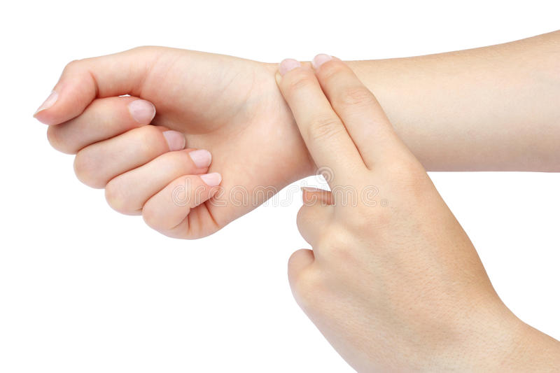

Table **figure 2.1**

|  |  |  |  |  |  |  |
| --- | --- | --- | --- | --- | --- | --- |
|  |  | Heart rate (beats/minute) | | | |  |
| subject | Exercise (hours per week ) | Trial 1 | Trial 2 | Trial 3 | average | gender |
| 1 | 2 | 70 | 72 | 68 | 70 | F |
| 2 | 5 | 76 | 70 | 70 | 72 | F |
| 3 | 4 | 66 | 68 | 66 | 67 | F |
| 4 | 2 | 66 | 62 | 72 | 67 | F |
| 5 | 4 | 50 | 50 | 41 | 48 | f |
| 6 | 0 | 96 | 88 | 86 | 90 | F |
| 7 | 2 | 54 | 52 | 70 | 59 | F |
| 8 | 2 | 78 | 76 | 78 | 77 | F |
| 9 | 4 | 71 | 74 | 72 | 72 | M |
| 10 | 4 | 86 | 84 | 82 | 82 | M |
| 11 | 3 | 80 | 80 | 80 | 80 | M |
| 12 | 3 | 66 | 77 | 70 | 71 | M |
| 13 | 3 | 76 | 72 | 68 | 72 | F |
| 14 | 0 | 82 | 72 | 78 | 77 | M |
| 15 | 1 | 94 | 102 | 100 | 99 | M |
| 16 | 5 | 50 | 45 | 72 | 56 | F |
| 17 | 2 | 64 | 76 | 42 | 61 | M |
| 18 | 0 | 74 | 66 | 62 | 67 | F |
| 19 | 3 | 74 | 68 | 76 | 73 | M |
| 20 | 5 | 74 | 64 | 70 | 69 | M |
| 21 | 3 | 62 | 72 | 76 | 70 | F |
| 22 | 5 | 66 | 70 | 74 | 70 | F |
| 23 | 5 | 78 | 76 | 62 | 72 | M |
| 24 | 3 | 70 | 62 | 62 | 65 | M |
| 25 | 6 | 70 | 62 | 60 | 64 | M |

Scatter plot **figure 2.2**

Amount of exercise (hours per week)

Average Heart rate (beats per minutes)

References

Laskowski, E., 2022. *What's a normal resting heart rate?*. [online] Mayo Clinic. Available at: <https://www.mayoclinic.org/healthy-lifestyle/fitness/expert-answers/heart-rate/faq-20057979#:~:text=A%20normal%20resting%20heart%20rate%20for%20adults%20ranges%20from%2060,to%2040%20beats%20per%20minute.> [Accessed 23 March 2022].

National Association of Chronic Disease Directors. 2022. *Cardiovascular Health - National Association of Chronic Disease Directors*. [online] Available at: <https://chronicdisease.org/page/cardiovascularhealth/> [Accessed 23 March 2022].

Mayo Clinic. 2022. *Heart failure - Symptoms and causes*. [online] Available at: <https://www.mayoclinic.org/diseases-conditions/heart-failure/symptoms-causes/syc-20373142#:~:text=Heart%20failure%20occurs%20when%20the,of%20the%20legs%20and%20feet.> [Accessed 23 March 2022].

Science Experiments for Kids. 2022. *How does exercise affect heart rate? - Science for Kids*. [online] Available at: <https://www.science-sparks.com/exercise-affect-heart-rate/> [Accessed 23 March 2022].

2022. [online] Available at: <https://www.dreamstime.com/photos-images/pulse.html> [Accessed 23 March 2022].